**Final Project: Web Design**

I created a website for my personal photographs. I went through the perspective that I was a professional photographer (which I am not) and people could ask me to shoot their events. Since I am trying to convince people to hire me, I tried to showcase as much of my work as possible. You can see this is very evident on my home page. I have a carousel of a variety of different shots as well as thumbnails displaying my work and links to my other pages. I wanted the overall website to be plain but neat. I didn’t want to distract from my photographs but I wanted to add a touch of personality.

I hope people look at my website and see someone who is passionate about what they do. I tried to make the site personal as well as informational. I have a section where you can learn about me personally or you can just look at some of my work. There is also a page where you can contact me for an event. Hopefully after looking at all my qualifications people will be inspired to hire me.

Overall, my focus was the photos. This determined what colors I used and where. Since I used only black and white, I hope this catches the users eye to the more colorful aspects of the page. When choosing what photographs I wanted to feature, I thought most about variety. I have pictures of people, places and nature. I believe this should display my strengths as well as give the site interesting content to look at.

I can’t say that I was necessarily inspired by one website. I find that I enjoy websites that are simple and straight forward. Sites that have more media and images tend to be less distracting. I wanted to make this site easy to use for every gernation as well as capture how I see the world though my camera lens.

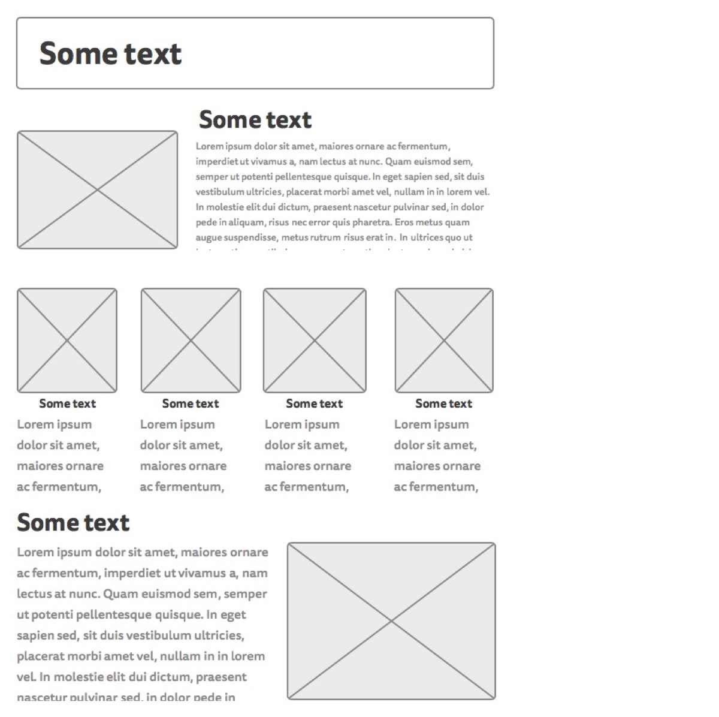

**How I Met the Requirements**

I believe I met many of the requirements of this project. Firstly, my home page featured a carousel photo slider along with 4 separate thumbnails that linked to my 4 other pages. There was also a page header, text and an extra picture. At the bottom of the page (and every page) there is contact information. I tried to get creative with my jumbotron header and do a camera underline. Every page featured the same background from subtlepatterns.com.

My first thumbnail leads to my book an event page. Here clients would type in their first name, last name, email, phone number and description of the event. Although this page is relatively simple it was an extra add on that fit the topic I chose.

My second thumbnail leads to my specialties. This page fulfills the bullet points requirement. I used a bootstrap version on an unordered list to display my skills as a photographer. Below the listed skills is a spot to talk about my methods and the camera I use.

My third thumbnail leads to my gallery. Here I have a variety of different enlarged pictures with a description for each one. This fulfills the image gallery requirement of at least 4 different images with text.

My forth thumbnail leads to an about me page. This page contains information about myself in multiple paragraphs and a large BORDERED picture of myself. I think this fulfills the news tory/article/statement requirement.

Every linked page has a navbar with functioning links to the rest of the pages. Each one is also properly titled on the browser tab. I believe all pages are visually appealing and structured. I found the colors fitting and not overwhelming. Everything is functional and had equal effort put into it.

**LINK TO SITE:** [**http://ist263.cloudapp.net/jlkalata/Final%20Project/**](http://ist263.cloudapp.net/jlkalata/Final%20Project/)